The Arab Spring
What is the Arab Spring
Tunisia’s Jasmine Revolution
Tunisia’s Leaders Flee
http://english.aljazeera.net/indepth/features/2011/01/201111684242518839.html
http://www.washingtonpost.com/wp-dyn/content/video/2011/01/21/VI2011012103872.html
Features The tragic life of a street vendor
Al Jazeera travels to the birthplace of Tunisia's uprising and speaks to Mohamed Bouazizi's family.
Yasmine Ryan Last Modified: 20 Jan 2011 15:00

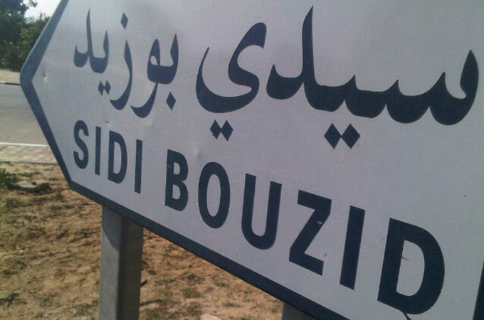
A town not previously recognised outside of Tunisia is now known as the place where a revolution began [Al Jazeera]
In a country where officials have little concern for the rights of citizens, there was nothing extraordinary about humiliating a young man trying to sell fruit and vegetables to support his family.
Yet when Mohamed Bouazizi poured inflammable liquid over his body and set himself alight outside the local municipal office, his act of protest cemented a revolt that would ultimately end President Zine El Abidine Ben Ali's 23-year-rule.
Local police officers had been picking on Bouazizi for years, ever since he was a child. For his family, there is some comfort that their personal loss has had such stunning political consequences.
"I don't want Mohamed's death to be wasted," Menobia Bouazizi, his mother, said. "Mohamed was the key to this revolt."
Simple, troubled life
Mohamed Bouazizi was 10 years old when he became the main provider for his family, selling fresh produce in the local market. He stayed in high school long enough to sit his baccalaureate exam, but did not graduate. (He never attended university, contrary to what many news organisations have reported).
Bouazizi's father died when he was three years old. His elder brother lives away from the family, in Sfax. Though his mother remarried, her second husband suffers from poor health and is unable to find regular work.
"He didn't expect to study, because we didn't have the money," his mother said.
IN VIDEO
Al Jazeera's Ayman Mohyeldin profiles the man whose suicide launched a revolution
At age of 19, Mohamed halted his studies in order to work fulltime, to help offer his five younger siblings the chance to stay in school.
"My sister was the one in university and he would pay for her," Samya Bouazizi, one of his sisters, said. "And I am still a student and he would spend money on me."
He applied to join the army, but was refused, as were other successive job applications. With his family dependant on him, there were few options other than to continue going to market.
By all accounts, Bouazizi, just 26 when he died earlier this month, was honest and hardworking. Every day, he would take his wooden cart to the supermarket and load it would fruit and vegetables. Then he would walk it more than two kilometres to the local souk.
Police abuse
And nearly everyday, he was bullied by local police officers.
"Since he was a child, they were mistreating him. He was used to it," Hajlaoui Jaafer, a close friend of Bouazizi, said. "I saw him humiliated."
The body of the man who started a revolution now lies in a simple grave, surrounded by olive trees, cactuses and blossoming almond trees.
The abuse took many forms. Mostly, it was the type of petty bureaucratic tyranny that many in the region know all too well. Police would confiscate his scales and his produce, or fine him for running a stall without a permit.
Six months before his attempted suicide, police sent a fine for 400 dinars ($280) to his house – the equivalent of two months of earnings.
The harassment finally became too much for the young man on December 17.
That morning, it became physical. A policewoman confronted him on the way to market. She returned to take his scales from him, but Bouazizi refused to hand them over. They swore at each other, the policewoman slapped him and, with the help of her colleagues, forced him to the ground.
The officers took away his produce and his scale.
Publically humiliated, Bouazizi tried to seek recourse. He went to the local municipality building and demanded to a meeting with an official.
He was told it would not be possible and that the official was in a meeting.
"It's the type of lie we're used to hearing," said his friend.
Protest of last resort
With no official wiling to hear his grievances, the young man brought paint fuel, returned to the street outside the building, and set himself on fire.
For Mohamed's mother, her son's suicide was motivated not by poverty but because he had been humiliated.
"It got to him deep inside, it hurt his pride," she said, referring to the police's harassment of her son.
The uprising that followed came quick and fast. From Sidi Bouzid it spread to Kasserine, Thala, Menzel Bouzaiene. Tunisians of every age, class and profession joined the revolution.
In the beginning, however, the outrage was intensely personal.
"What really gave fire to the revolution was that Mohamed was a very well-known and popular man. He would give free fruit and vegetables to very poor families," Jaafer said.
It took Ben Ali nearly two weeks to visit Mohamed Bouazizi's bedside at the hospital in Ben Arous. For many observers, the official photo of the president looking down on the bandaged young man had a different symbolism from what Ben Ali had probably intended.
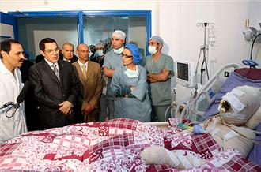
Tunisian president paid a visit to Bouazizi in hospital [AFP]
Menobia Bouazizi said the former president was wrong not to meet with her son sooner, and that when Ben Ali finally did reach out to her family, it was too late - both to save her son, and to save his presidency.
He received members of the Bouazizi family in his offices, but for Menobia Bouazizi, the meeting rang hollow.
"The invite to the presidential palace came very late," she said. "We are sure that the president only made the invitation to try to derail the revolution."
"I went there as a mother and a citizen to ask for justice for my son."
"The president promised he would do everything he could to save our son, even to have him sent to France for treatment."
The president never delivered on his promises to her family, Menobia Bouazizi said.
Contagious uprising
But by the time Menobia Bouazizi's son died of his burns on January 4, the uprising had already spread across Tunisia.
Fedya Hamdi, the last police officer to antagonise the street vendor, has since fled the town. She was reportedly dismissed, but her exact whereabouts are unknown.
Meanwhile, the body of the man who started a revolution now lies in a simple grave outside Sidi Bouzid, surrounded by olive trees, cactuses and blossoming almond trees.
He is sorely missed by his family, whose modest house is now one of the busiest in Sidi Bouzid, with a steady flow of journalists who have only just discovered the town where it all began.
"He was very sincere," Basma Bouazizi, his shy 16-year-old sister, said. "We are like soulless bodies since he left."
"We consider him to be a martyr," Mahmoud Ghozlani, a local member of the Progressive Democratic Party (PDP), said in an interview metres away from the spot where the street vendor set himself on fire.
Proof itself of the progress made in four short weeks: such an interview with an opposition activist on the streets of Sidi Bouzid would not have been possible until the day Bouazizi inspired the revolt.
Part One of a two-part series. See also: How the people of Sidi Bouzid launched a revolution.

